Practical - 3
Practical Title: Responsive UI Design using CSS Grid, Flexbox, and Bootstrap/Tailwind

Problem Definition: Design responsive layouts for Home, About, Registration, Dashboard, and Events pages using CSS Grid and Flexbox. Optional to use CSS framework such as Bootstrap or Tailwind. Ensure mobile-first responsiveness.

Theory
1. How does the layout adapt for mobile, tablet, and desktop screens?
The layout currently has limited responsiveness for mobile, tablet, and desktop screens. Some elements use flexible properties such as percentages, but fixed widths, margins, padding, and table layouts can cause horizontal scrolling on smaller screens. Media queries and responsive units such as %, vw, and rem have not been used consistently. Therefore, the layout works better on desktop screens but should be improved with CSS media queries and flexible layouts such as Flexbox or Grid for proper mobile and tablet support.

2. Which layout technique is used and why?
The layout mainly uses HTML tables, CSS Flexbox, and basic positioning. Tables are used to arrange tabular data and some page sections, while Flexbox is used in places such as the header area to arrange elements horizontally with gaps. CSS properties like margin, padding, width, and position are also used for alignment and spacing. This approach is simple to implement and suitable for a basic student portal, but Flexbox or CSS Grid would be better for creating a responsive and modern page layout.

3. Are typography, spacing, colors, and contrast readable?
Yes, the typography, spacing, colors, and contrast are generally readable. The website uses clear fonts such as Segoe UI and Arial, with suitable font sizes and spacing between elements. The blue and white color combination provides good contrast, making the text easy to read. However, some pages use large fixed margins and inline styles, which can affect readability on smaller screens. Overall, the design is readable, but spacing and font sizes could be made more responsive.

4. Is the framework used consistently without unnecessary inline CSS?
No, the framework is not used completely consistently because the website contains a significant amount of inline CSS. Many elements use the style attribute for properties such as margin, padding, width, border, font size, and text alignment, while other styling is placed in external CSS files. It would be better to move the inline CSS into the respective external CSS files to make the code cleaner, easier to maintain, and more consistent.

Implementation/ Output/Result
Style:
CSS Selectors
body
.box
h1
hr
p
.footer
.footer a
.footer a:hover

CSS Properties
background
font-family
width
margin
padding
border-radius
border
box-shadow
color
font-size
line-height
text-align
text-decoration
font-weight

CSS Values Used
#dbeafe
#163172
white
#333
center
justify
none
bold
auto
15px
35px
40px
32px
18px
1.8
5px
80%

Effects Used
Background color
Font styling
Width and spacing
Padding
Rounded corners
Border
Box shadow
Text alignment
Text color
Link styling
Hover effect

Evidence of Work (Screenshots)
Webpages with CSS screenshots:
Homepage:
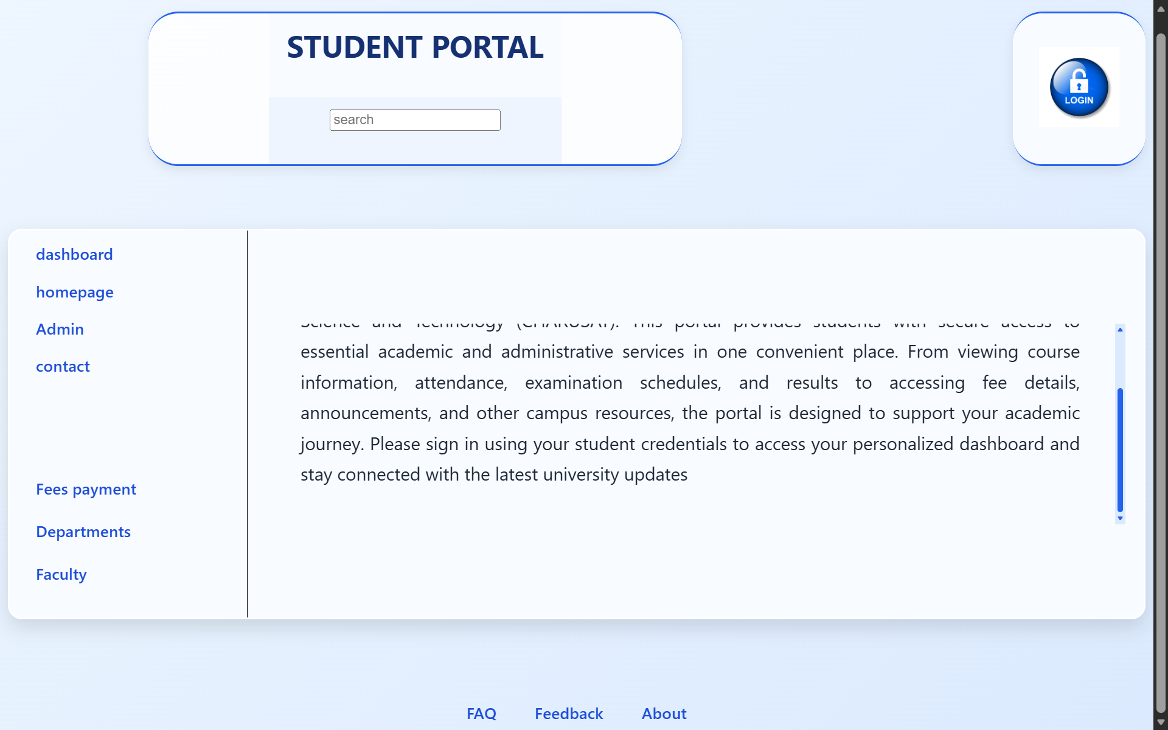
Student dashboard:
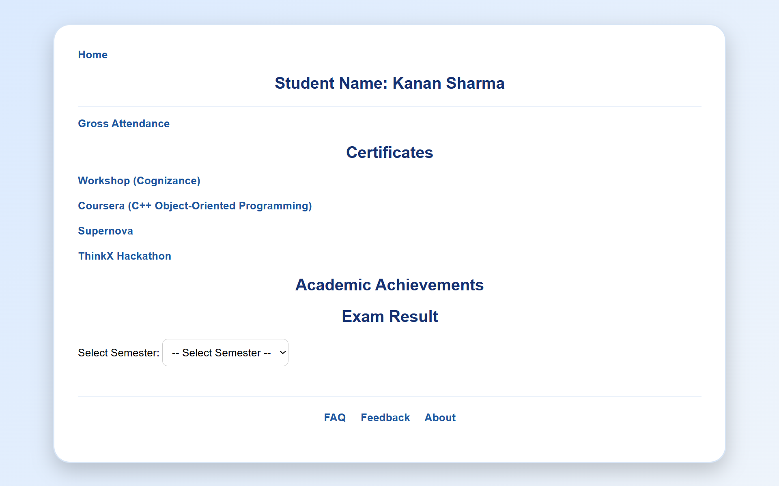

Admin:

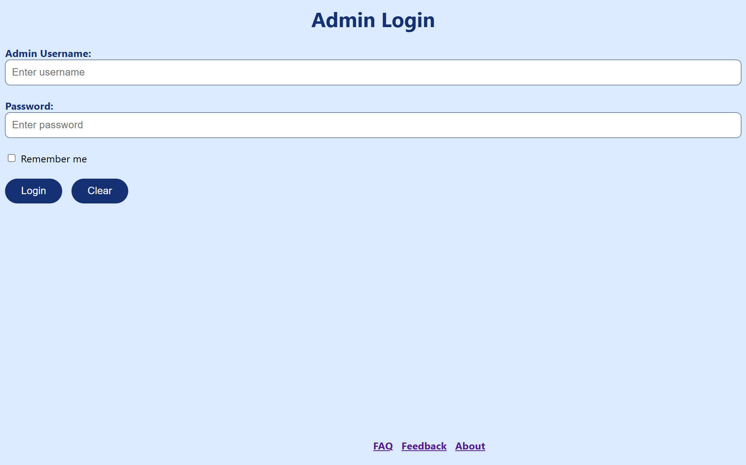

Contact Us:
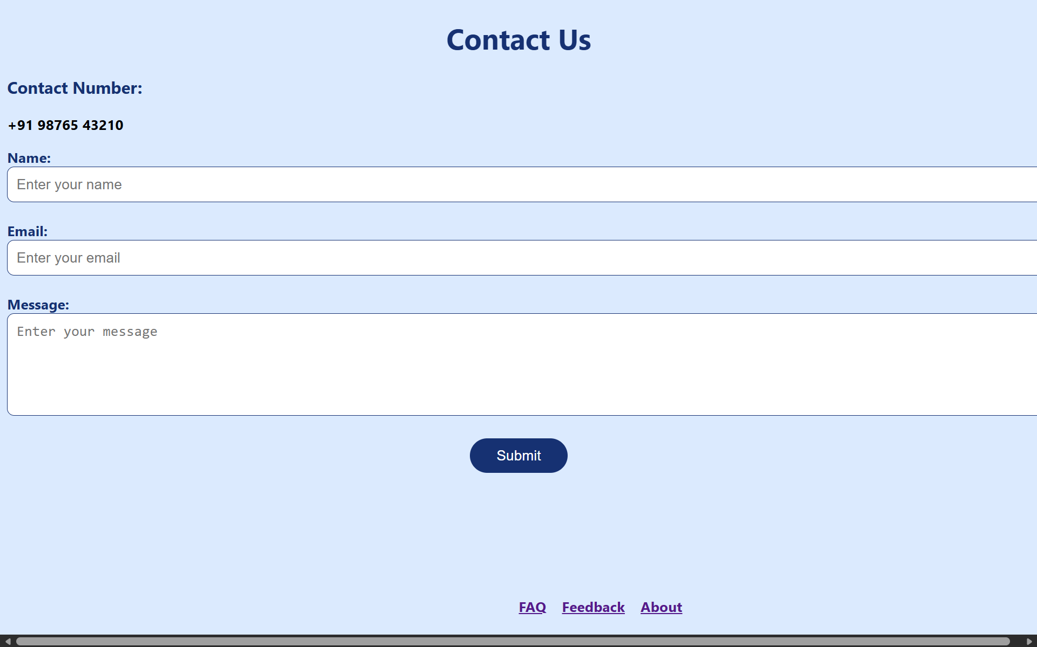

Fee Payment Gateway:
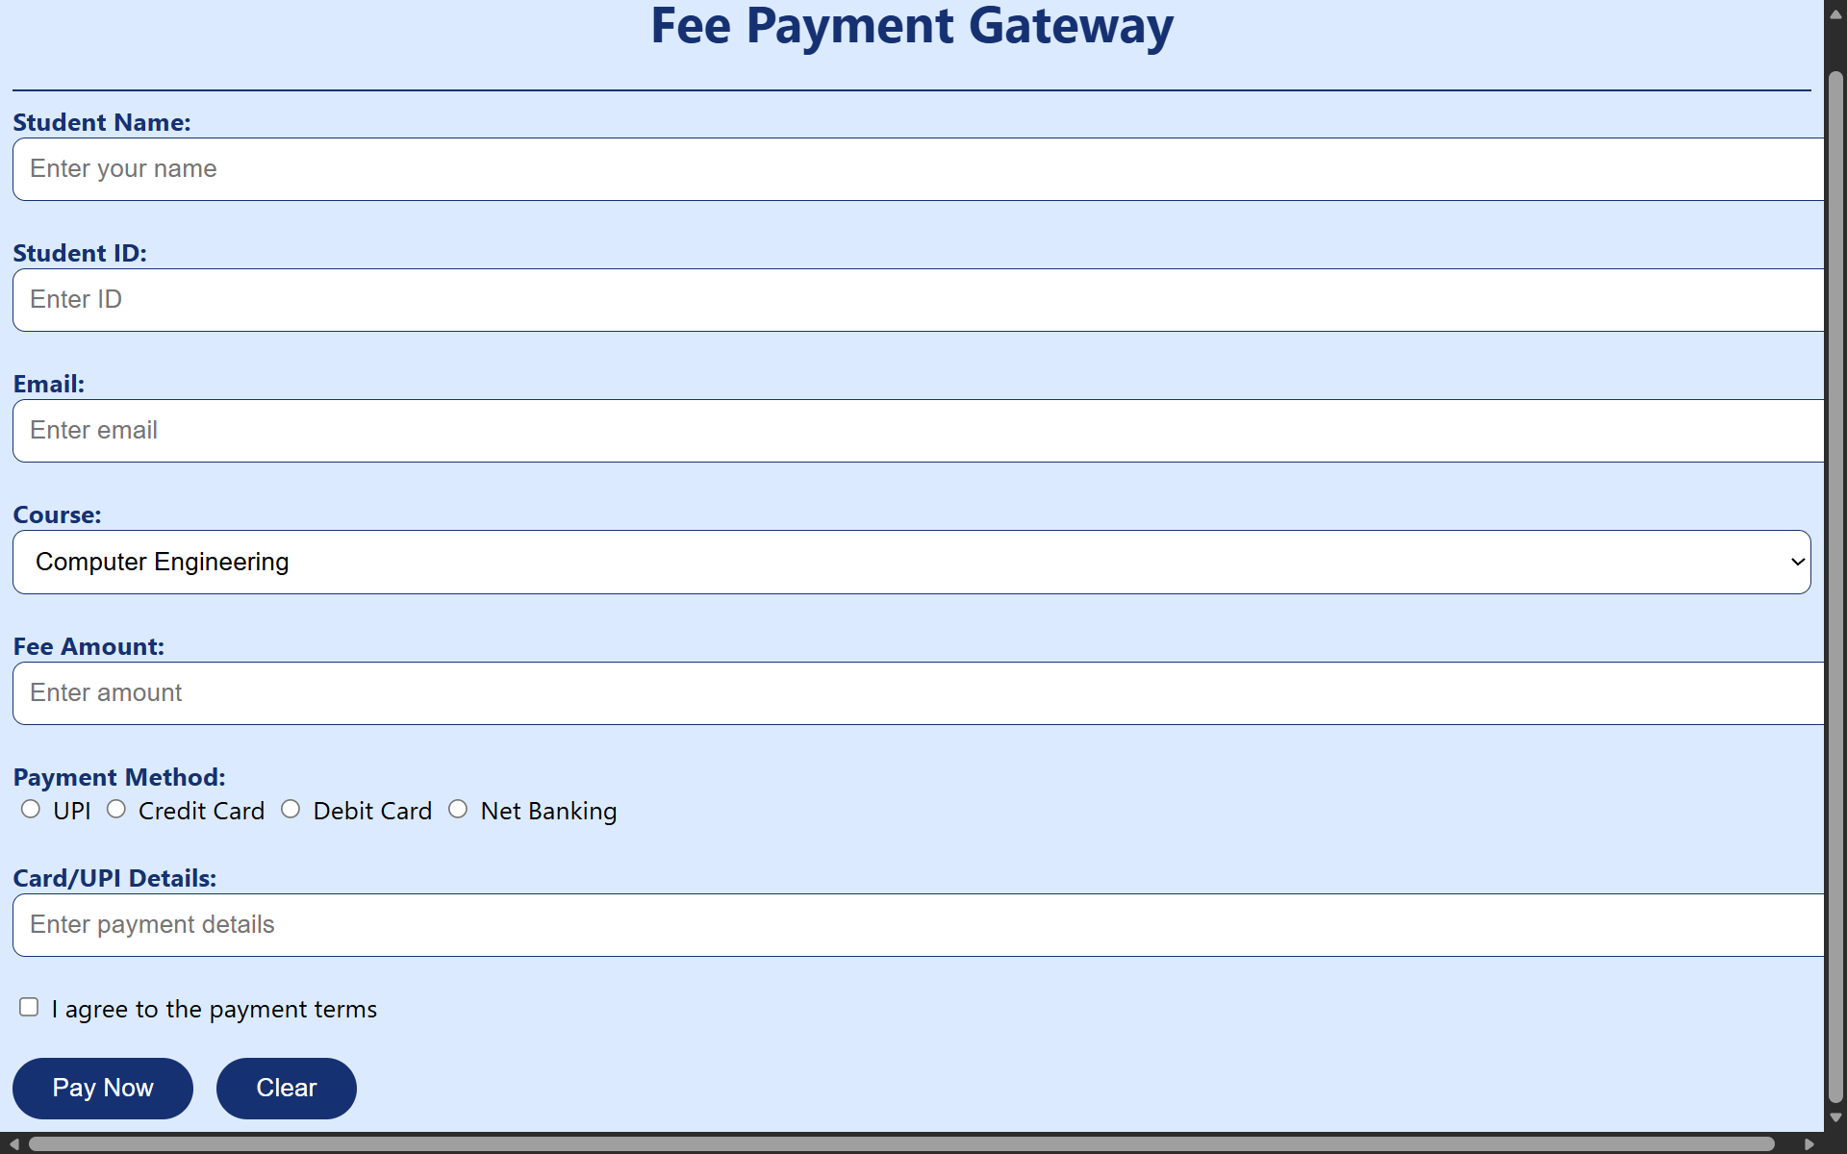

Departments:
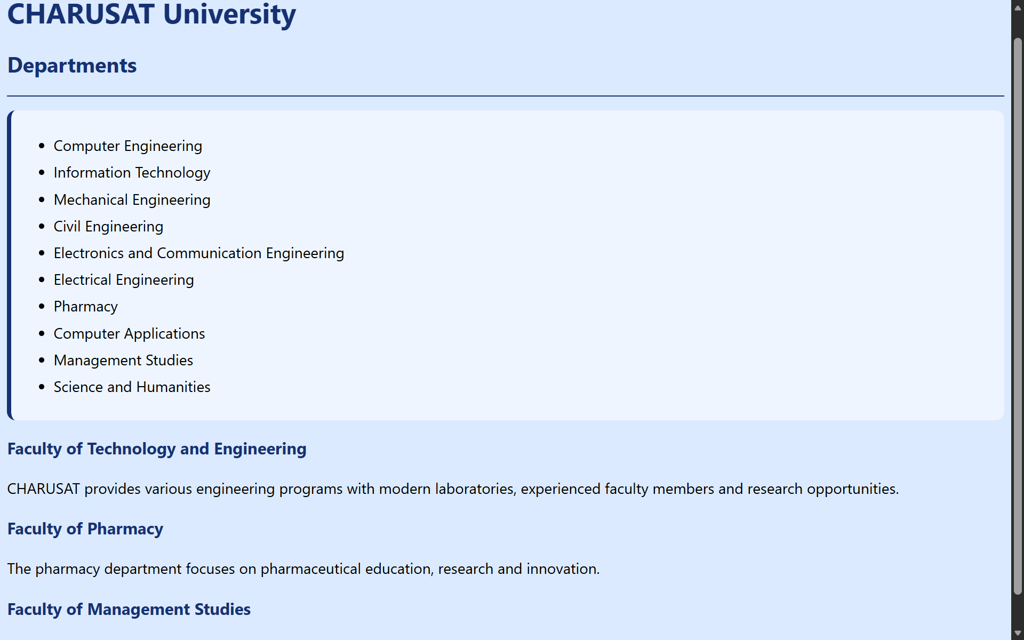

Faculty:
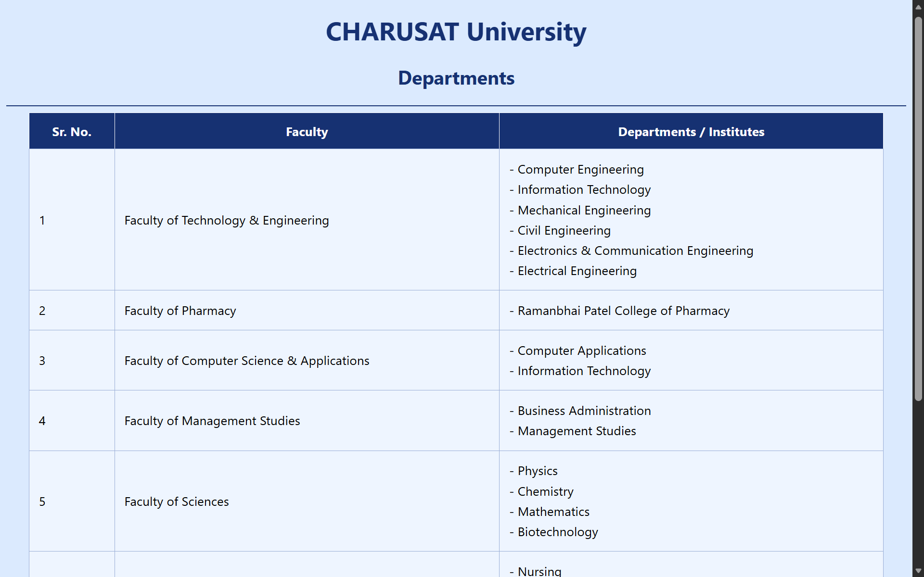

FAQs:
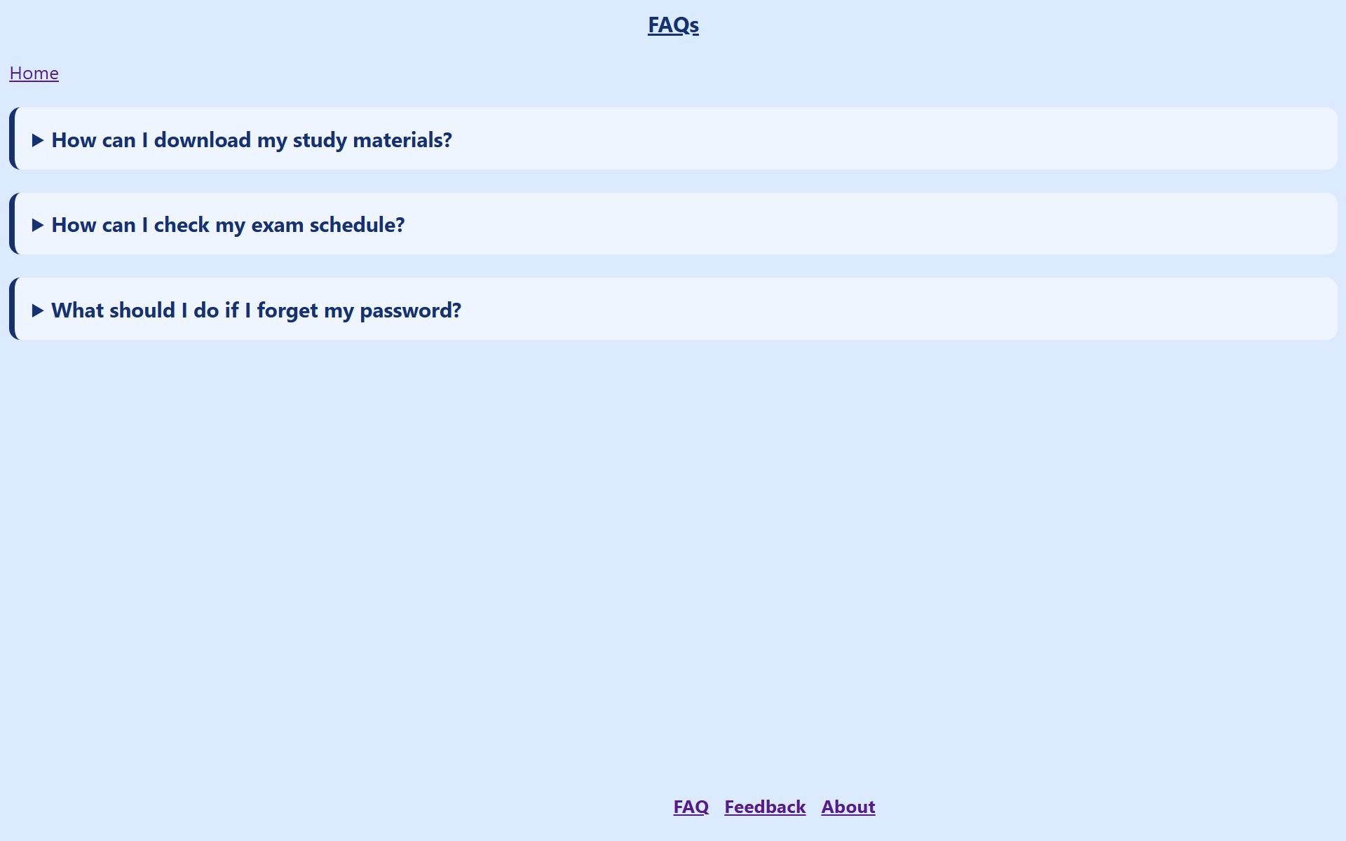

Feedback page:
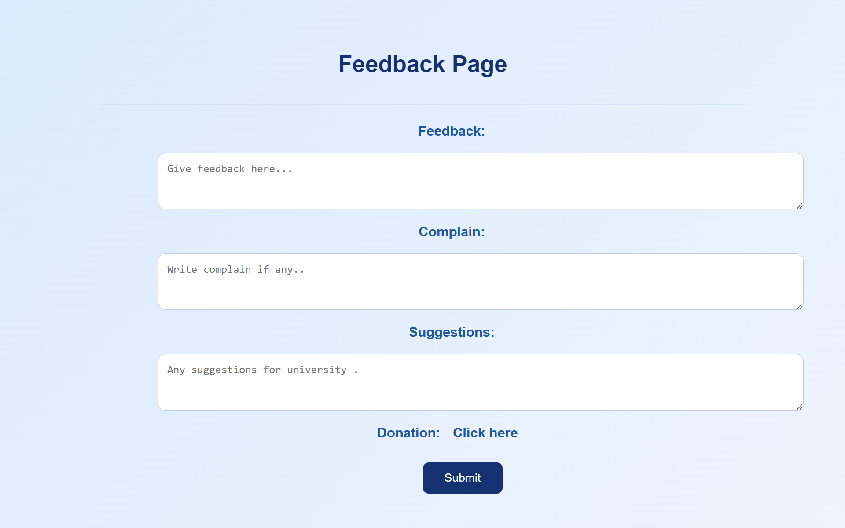

About:


GitHub Repository Link:

https://github.com/kanan2007s-sys/Web-development-/tree/main

Challenges Faced:

I faced challenge in designing the webpages . I couldn’t align them in the desired manner. The color combination also took some time.

Learning Outcomes:

I learned how to css with HTML . I also learned three types of CSS. How to use CSS with HTML file by giving the path and using the link tag.

Faculty Remarks:

